**Prometheus installation**

What is prometheus ?

Prometheus is a software application user for event monitoring and alerting,

time serices database

Why use?

Records any purly numeric time serices

Machine-centric and highly dynamic service oriented architectures

Prometh

1.ubuntu@ip-172-31-25-79:~$ sudo useradd prometheus

2.ubuntu@ip-172-31-25-79:~$ sudo mkdir /etc/prometheus

3.ubuntu@ip-172-31-25-79:~$ sudo mkdir /var/lib/prometheus

4.ubuntu@ip-172-31-25-79:~$ wget https://github.com/prometheus/prometheus/releases/download/v2.35.0/prometheus-2.35.0.linux-amd64.tar.gz

5.ubuntu@ip-172-31-25-79:~$ sudo chown prometheus:prometheus /var/lib/prometheus

6.ubuntu@ip-172-31-25-79:~$ tar -xvf prometheus-2.35.0.linux-amd64.tar.gz

7.ubuntu@ip-172-31-25-79:~$ mv prometheus-2.35.0.linux-amd64 prometheus-files

8.ubuntu@ip-172-31-25-79:~$ sudo cp prometheus-files/prometheus /usr/local/bin/

9.ubuntu@ip-172-31-25-79:~$ sudo cp prometheus-files/promtool /usr/local/bin/

10.ubuntu@ip-172-31-25-79:~$ sudo chown prometheus:prometheus /usr/local/bin/prometheus

11.ubuntu@ip-172-31-25-79:~$ sudo chown prometheus:prometheus /usr/local/bin/promtool

1. ubuntu@ip-172-31-25-79:~$ sudo vi /etc/prometheus/prometheus.yml      (to add the ips)

global:

  scrape_interval: 15s

  external_labels:

    monitor: 'prometheus'

scrape_configs:

  - job_name: 'node_exporter'

    static_configs:

      - targets: ['ec2-13-58-127-241.us-east-2.compute.amazonaws.com:9100']

13.ubuntu@ip-172-31-25-79:~$ sudo chown prometheus:prometheus /etc/prometheus/prometheus.yml

14.ubuntu@ip-172-31-25-79:~$ sudo vi /etc/systemd/system/prometheus.service

[Unit]

Description=Prometheus

Wants=network-online.target

After=network-online.target

[Service]

User=prometheus

Group=prometheus

Type=simple

ExecStart=/usr/local/bin/prometheus \

    --config.file /etc/prometheus/prometheus.yml \

    --storage.tsdb.path /var/lib/prometheus/ \

    --web.console.templates=/etc/prometheus/consoles \

    --web.console.libraries=/etc/prometheus/console_libraries

[Install]

WantedBy=multi-user.target

15.ubuntu@ip-172-31-25-79:~$ sudo chown -R prometheus:prometheus /etc/prometheus/consoles

16.ubuntu@ip-172-31-25-79:~$ sudo systemctl daemon-reload

17.ubuntu@ip-172-31-25-79:~$ sudo systemctl start prometheus

18.ubuntu@ip-172-31-25-79:~$ sudo systemctl status prometheus

Remember that ec2-13-58-127-241.us-east-2.compute.amazonaws.com is the DNS value of node-exporter installed Ec2 instance.

** Restart Prometheus service.

   sudo systemctl restart prometheus

Try It Out

Now in your browser navigate to http://ec2-3-17-28.53.us-east-2.compute.amazonaws.com:9090/targets . Remember to change the url accordingly to your Prometheus AWS EC2 instance details

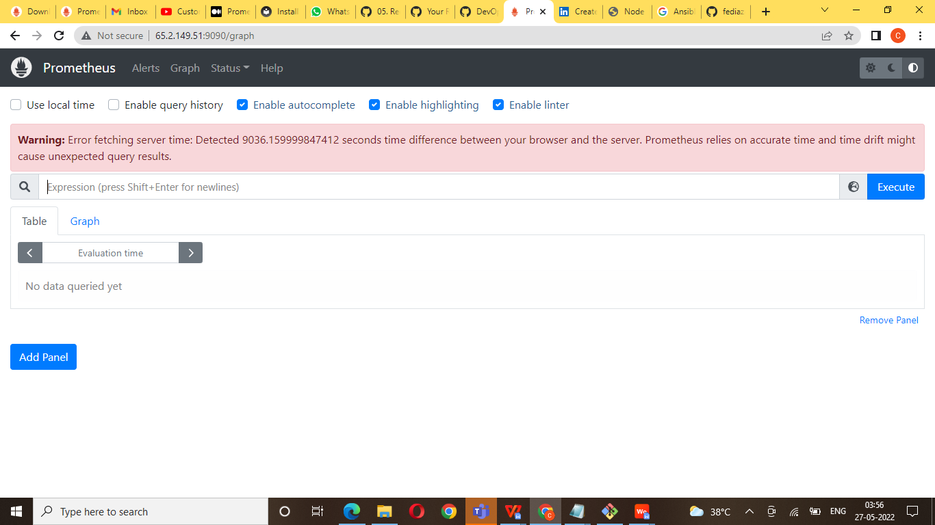

Prometheus installation link below

https://devopscube.com/install-configure-prometheus-linux/

Node exported

What is a node exporter?

Node Exporter is a Prometheus exporter for server level and OS level metrics with configurable metric collectors. It helps us in measuring various server resources such as RAM, disk space, and CPU utilization

Create instance ec2 Ubuntu port no : 9100

Connect terimaninal

1. wget    <https://github.com/prometheus/node_exporter/releases/download/v1.3.1/node_exporter-1.3.1.linux-amd64.tar.gz>

1. tar -xvf node_exporter-1.3.1.linux-amd64.tar.gz

1. cd node_exporter-1.3.1.linux-amd64

sudo cp node_exporter /usr/local/bin/

5  cd ..

6  sudo useradd --no-create-home --shell /bin/false node_exporter

    7  sudo chown node_exporter:node_exporter /usr/local/bin/node_exporter

8  sudo vi /etc/systemd/system/node_exporter.service

[Unit]

Description=Node Exporter

Wants=network-online.target

After=network-online.target

[Service]

User=node_exporter

Group=node_exporter

Type=simple

ExecStart=/usr/local/bin/node_exporter

[Install]

WantedBy=multi-user.targ

9  sudo systemctl daemon-reload

10  sudo systemctl start node_exporter

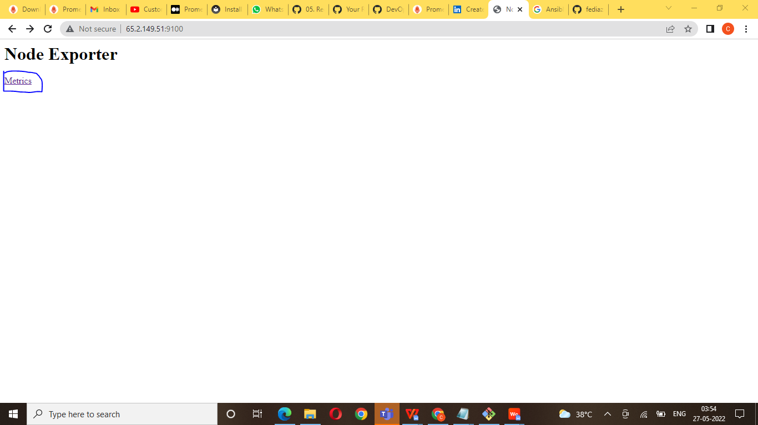

Grafana

Grafana  is a [multi-platform](https://en.wikipedia.org/wiki/Multi-platform) [open source](https://en.wikipedia.org/wiki/Open_source) analytics and [interactive visualization](https://en.wikipedia.org/wiki/Interactive_visualization) web application. It provides charts, graphs, and alerts for the web when connected to supported data sources.

Grafana install:

1.

* Create one file.sh

$ Touch install_grafana

* Edit file

$ Vi install_grafana

 #!/bin/bash

sudo apt-get install -y adduser libfontconfig1  
wget <https://dl.grafana.com/oss/release/grafana_7.3.4_amd64.deb>sudo dpkg -i grafana_7.3.4_amd64.deb  
sudo systemctl daemon-reload  
sudo systemctl start grafana-server  
sudo systemctl status grafana-server  
sudo systemctl enable grafana-server.service

Save and exit

Grafana install

$ sh install_grafana.sh

Now open it on the browser using below url:

Make sure that port 3000 is open for this instance.

http:// yourip:3000

Login username and password :admin and password admin